Bahria University,

Karachi Campus



LAB EXPERIMENT NO.

___03___

LIST OF TASKS

|  |  |
| --- | --- |
| TASK NO | OBJECTIVE |
| **01** | Display Product’s name and their supplier’s name (ContactName), whose supplier’s name doesnot contain Dirk and there should be at most 7 characters in Product’s name. |
| **02** | Create a report showing order ID. OrderDate. EmployeeID, and the firstname and LastName of the associated Employee (Tables: Employees & Orders ) |
| **03** | List distinct cities from of customers and suppliers, country must be Germany. |
| **04** | List all cities (duplicate values allowed) from of customers and suppliers |
| **05** | lists all customers and suppliers (ContactName, City, Country) |
| **06** | Count no of Products’s against each suppliers name. list only those products whose count is greater than 3. |
| **07** | Display Region ID, Region Description, Territories Description and (inner join with table Territories and Region). |
| 08 | Display Company Name and Total orders placed by the company (Table: orders, customer, use inner join, group by). |

Submitted On:

22-03-2023

(Date: DD/MM/YY)

**Task 01:** Display Product’s name and their supplier’s name (ContactName), whose supplier’s name doesnot contain Dirk and there should be at most 7 characters in Product’s name.

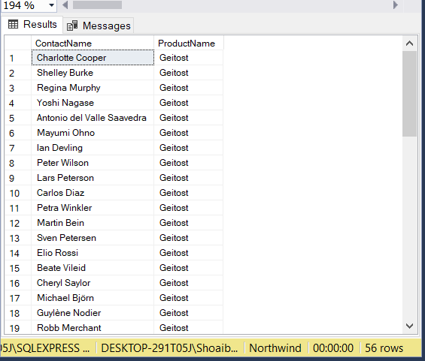**Solution:** select ContactName,ProductName from Suppliers,Products where ContactName not like '%Dirk%' and ProductName like '_______'

**Output:**

**Task 02:** Create a report showing order ID. OrderDate. EmployeeID, and the firstname and LastName of the associated Employee (Tables: Employees & Orders )

**Solution:** select FirstName,LastName,OrderID,OrderDate from Employees inner join Orders on Employees.EmployeeID=Orders.EmployeeID

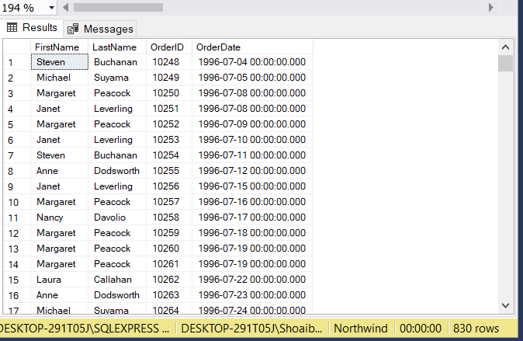**Output:**

**Task 03:** List distinct cities from of customers and suppliers, country must be Germany.

**Solution:** select distinct City,Country from Customers where Country='Germany'

union

select distinct City,Country from Suppliers where Country='Germany'

**Output:**

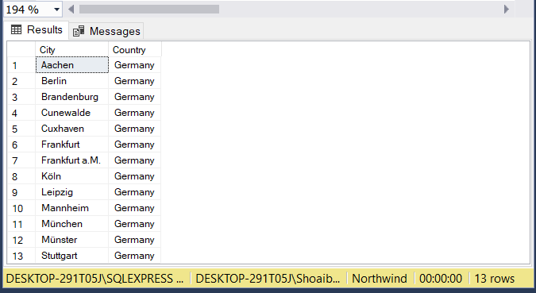

**Task 04:** List all cities (duplicate values allowed)from of customers and suppliers

**Solution:** select City from Customers

union all

select City from Suppliers

**Output:**

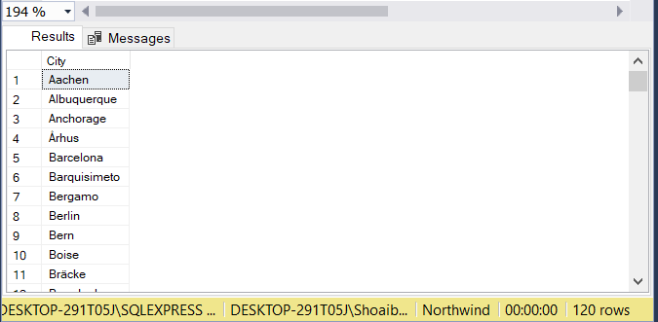

**Task 05:** lists all customers and suppliers (ContactName, City, Country)

**Solution:** select ContactName, City, Country from Customers

union

select ContactName, City, Country from Suppliers

**Output:**

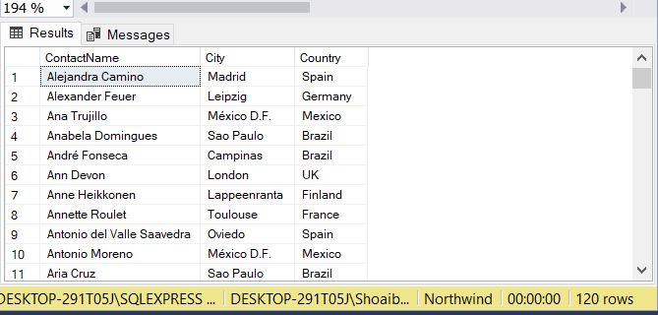

**Task 06:** Count no of Products’s against each suppliers name. list only those products whose count is greater than 3

**Solution:** select Suppliers.CompanyName, COUNT(*) As Prompt from Products Join Suppliers on Products.SupplierID=Suppliers.SupplierID group by CompanyName having Count(*)>3

**Output:**

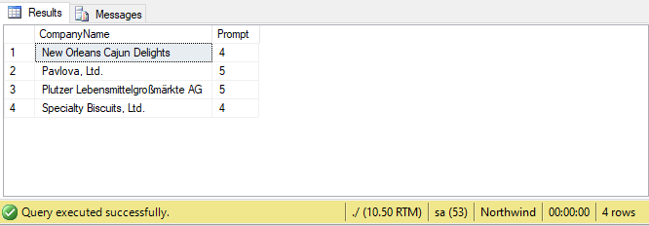

**Task 07:** Display Region ID, Region Description, Territories Description and (inner join with table Territories and Region).

**Solution:**select Region.RegionID,Region.RegionDescription,Territories.TerritoryDescription from Region Inner join Territories on Region.RegionID=Territories.RegionID

**Output:**

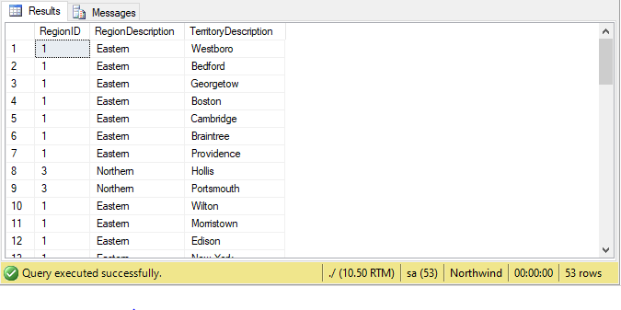

**Task 08:** Display Company Name and Total orders placed by the company (Table: orders, customer, use inner join, group by).

**Solution:** select CompanyName,COUNT(OrderID) as TotalOrders from Orders inner join Customers on Orders.CustomerID=Customers.CustomerID group by CompanyName

**Output:**

